The Official Magazine
of Sun City Summerlin

www.suncitylink.com

2019

Media Kit

Link

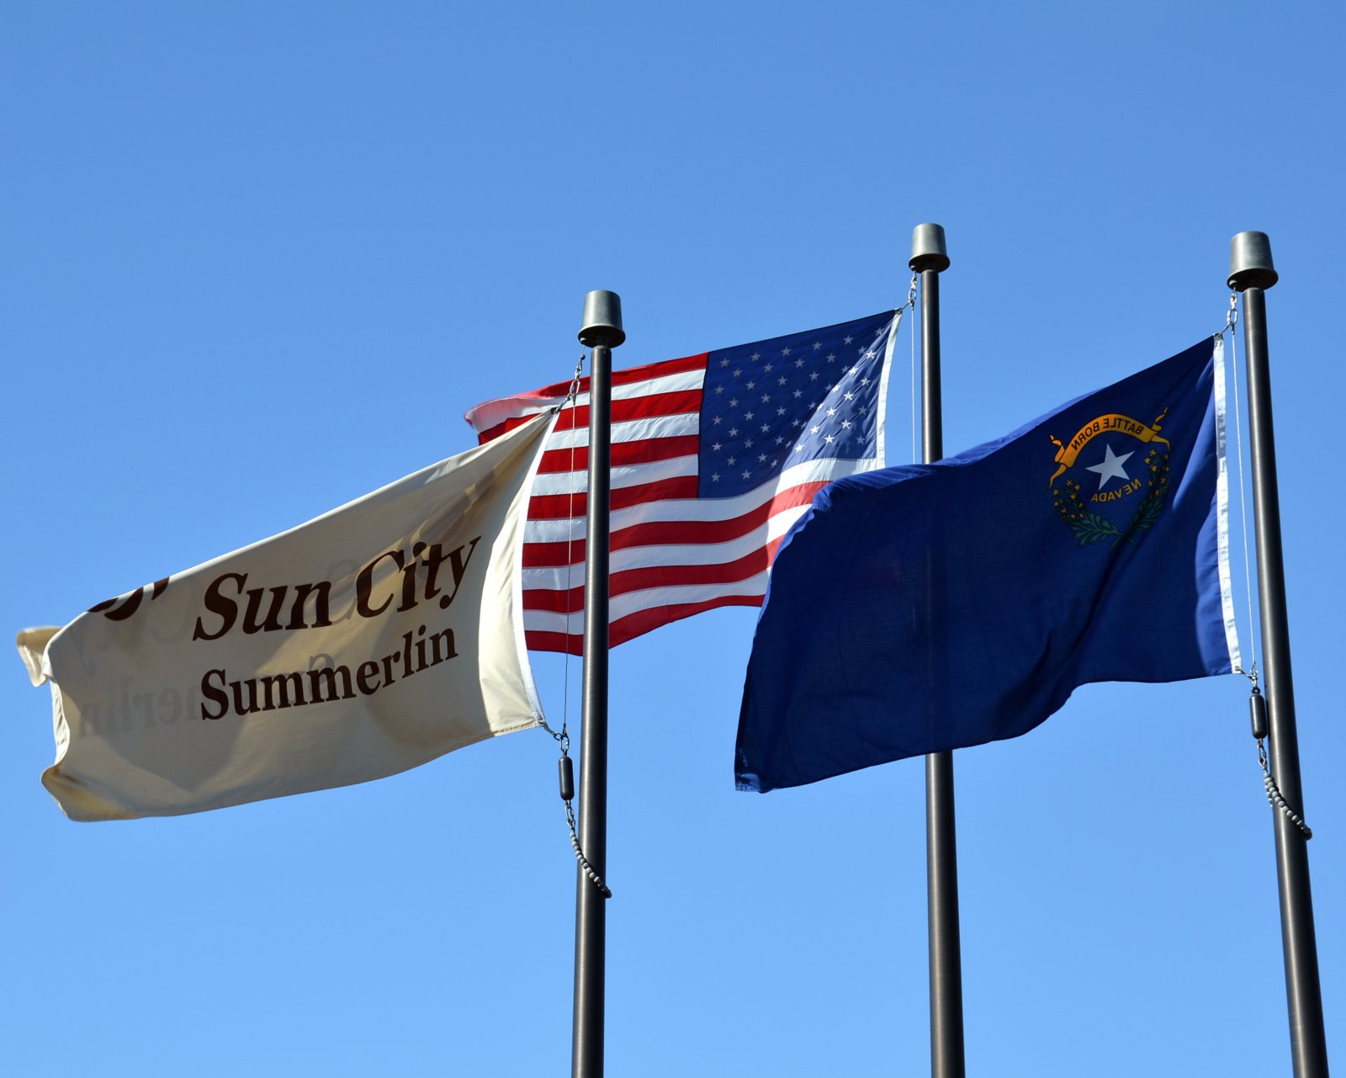

Located in the picturesque locality of Summerlin, the largest and most distinguished master-planned community in the Las Vegas Valley, Sun City Summerlin is a 55-and-over, age-restricted community nestled against the Spring Mountains, a short distance from the Las Vegas Strip.

Organized by the Del Webb Corporation in 1990, Sun City Summerlin is one of the nation’s premiere active adult communities and the largest homeowners association in the state of Nevada. Our master-planned development is composed of nearly 8,000 homes and 14,000 residents. According to the January 2013 list of community club holders, the average age for a Sun City resident is 73 years old, and is made up of 55% female and 45% male residents.

The Link is Sun City Summerlin’s official community magazine, our 70+ page monthly publication is direct-mailed to over 8,000 addresses monthly with an additional surplus of 500+ copies given to inquiring parties, potential residents and current advertisers.

PDF versions of the magazine are available on our website, www.suncityLink.com and on the Community Association website, www.scscai.com.

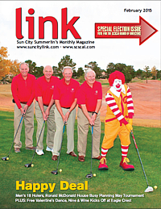
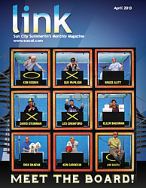

ADVERTISING IN THE LINK

There are several options for adverting in the Link, ranging in size and price. Below is a breakdown and description of the different types of ads. Advertising space is open to any entity with a valid Nevada business license. All new advertisers must submit a copy of their business license to the Link Magazine. The Link reserves the right to determine ad placement in each issue. In addition to the printed magazine, ads appear online, at www.suncitylink.com, in the PDF version of the magazine. Lastly, all advertisers are encouraged to take advantage of a free weekly online profile feature.

SERVICE DIRECTORY LISTING: Required 3-month minimum contract. The Service Directory can be found toward the back of the book. The listing consists of one (1) line, 6-8 words plus a phone number. Businesses are categorized under a suitable group.
- Two font options: bold and light face with pricing is as follows:
  - $30 per month for light face ($90 total for 3 months).
  - $35 per month for bold ($105 total for 3 months).
- Service directory contracts MUST be paid in full at the time of contract signing; monthly payment options are NOT available.

INSERTS: There are several options available to an advertiser in regards to an insert; in all cases the prints can be two-sided, front and back; and can be any paper weight and finish of your choosing. An insert can be any flier/brochure/information packet/posters. Advertisers must provide 8,300 copies of their ad to the Link’s printing company, Rapid Color. The material submitted is inserted into the middle of the magazine. Each and every copy of the Link placed in the mail is sealed in a poly-bag to ensure that inserts are securely intact. Pricing is as follows:
- $800 for 8.5” X 11” standard sized flier.
- $825 for any brochures SMALLER than standard 8.5” X 11” size or shaped differently.
  - For example: home shaped fliers for realtors, car shaped fliers for car dealers, half page mailers, small calendars, etc.
- $1,400 for any stapled packets (no more than 10 pages) and/or any poster/large fliers.
  - All posters/large fliers must be folded to an 8½” X 11”.

IMPORTANT INFORMATION:
- A copy of your insert must be submitted to the Link for approval PRIOR to print & delivery.
  - The Link reserves the right to deny/reject any insert we deem inappropriate for our audience.
- Advertisers are required to provide and deliver 8,300 copies of their insert to our printing company, Rapid Color, 702-792-6055, located at 6425 Karms Park Ct. Las Vegas, NV 89118.
- The maximum size of any flier is 8.5” X 11”
  - Anything larger must be folded so that it measures no larger than the standard 8.5” X 11” size.
- All 8,300 copies of your insert is due to Rapid Color no later than the 11th of the month PRIOR to publication.
  - January 11th for the February issue; February 11th for March; March 11th for April; etc.
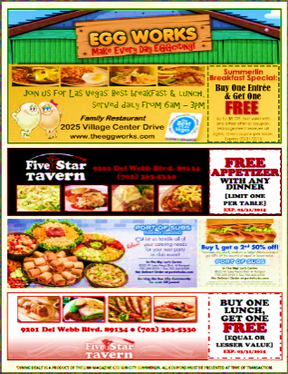
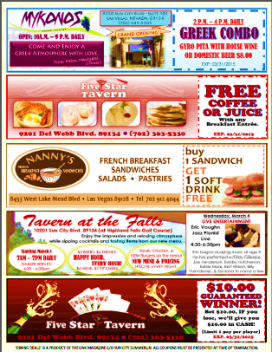
DINING DEALS: An exclusive offer to all restaurants, bars, and food & beverage-based businesses. The Link understands that restaurants have different advertising needs. We have come up with a great product that has proven to be extremely successful. Each month, the Link designs a flier make up of ads from all of our food & beverage-based clients. The flier is printed and inserted in each issue – this was a conscious choice on our end as we found that residents much prefer to be able to take a flier and place it in their purses or fold it into their wallet. One copy is mailed to each home via the Link and thousands of additional copies available in the four community centers located throughout Sun City Summerlin. Most residents ask for several additional copies, some taking enough copies to pass out to their neighbors, family and friends.
- 1 Dining deal ad measures 8” wide X 2” tall and costs $200.
  - Multiple spaces can be combined to create larger ads; cost is multiplied by the number of spaces occupied.
- Space is limited; ads are on a first-come, first-served basis.
- No term commitments necessary.

DISPLAY ADS: Display ads are the ads that can be found throughout the magazine and range in size and price. The smallest available size being our baby business card, measuring 2.5” X 1.75”, while our largest ad size is a full page ad measuring 7.5” X 10”. Ad space is limited and signed contracts are required. Complimentary artwork design is available with all valid contracts.

IMPORTANT INFORMATION:
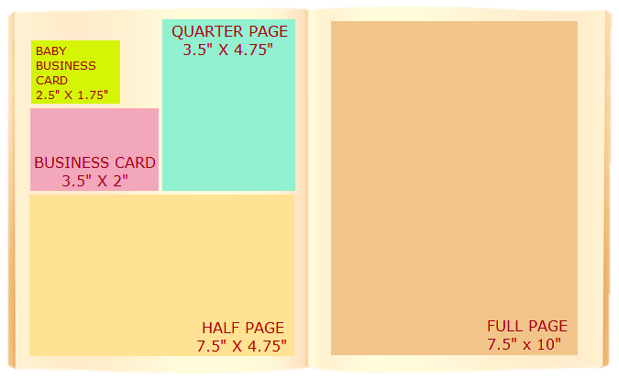
Display advertisement is confirmed when a signed contract is received. Due to limited space availability and ad placement priority, we ask that contracts are signed and returned to our office as soon as possible. Our deadlines are always 30 days ahead, January 1 for the February issue; February 1 for the March issue; March 1 for the April issue and so on.
The artwork deadline is always the third of the month PRIOR to issue by 2 p.m. January 3 for the February issue; February 3 for the March issue; March 3 for the April issue and so on.
Extensions can be granted on a case by case basis; inquire with our advertiser coordinator, Dianne Pontillas. Any extension requests must be received by the 3rd in lieu of the ad. ALL ARTWORK MUST BE SCALED TO SIZE AND MUST BE AT LEAST 300DPI. ALL inkjet, output copies, pre-published ads and faxes are NOT considered camera-ready and will not be accepted for publication.
B&W: Black and White Ad
SIZE & TERMS | 1 Month | 3 Months | 6 Months | 12 Months
BABY BUSINESS CARD  2½” x 1¾ “ (Horizontal)  ONLY 10 SPACES AVAIL | B&W: $184  Color: $212 | B&W: $498 ($166mo)  Color: $573 ($191mo) | B&W: $900 ($150mo)  Color: $1,038 ($173mo) | B&W: $1,584 ($132mo)  Color: $1,824 ($152mo)
BUSINESS CARD  3½” x 2” (Horizontal) | B&W: $240  Color: $276 | B&W: $667 ($222mo)  Color: $765 ($255mo) | B&W: $1,236 ($206mo)  Color: $1,422 ($237mo) | B&W: $2,256 ($188mo)  Color: $2,592 ($216mo)
VERTICAL AD SPACE  1⅞” x 4¾” (Vertical)  ONLY 2 SPACES AVAIL | B&W: $299  Color: $344 | B&W: $810 ($270mo)  Color: $933 ($311mo) | B&W: $1,482 ($247mo)  Color: $1,704 ($284mo) | B&W: $2,688 ($224mo)  Color: $3,096 ($258mo)
QUARTER PAGE  3½” x 4¾” (Vertical) | B&W: $460  Color: $529 | B&W: $1,260 ($420mo)  Color: $1,449 ($483mo) | B&W: $2,280 ($380mo)  Color: $2,622 ($437mo) | B&W: $4,140 ($345mo)  Color: $4,764 ($397mo)
HALF PAGE  7½” x 4¾” OR 3½” X 10”  (Horizontal/Vertical) | B&W: $805  Color: $926 | B&W: $2,190 ($730mo)  Color: $2,520 ($840mo) | B&W: $3,966 ($661mo)  Color: $4,560 ($760mo) | B&W: $7,248 ($604mo)  Color: $8,340 ($695mo)
FULL PAGE  7½” x 10” (Vertical) | B&W: $1,351 color: $1,554 | B&W: $3,795 ($1,265mo)  Color: $4,365 ($1,455mo) | B&W: $7,074 ($1,179mo)  Color: $8,136 ($1,356mo) | B&W: $13,116 ($1093mo)  Color: $15,084 ($1257mo)
INSIDE/OUTSIDE FRONT OR BACK COVERS |  |  | (COLOR ONLY) Full Page: $16,596 ($1,383mo)  (COLOR ONLY) Half Page: $11,592 ($966mo)  1 YEAR CONTRACT REQUIRED

Deadlines which fall on a weekend day are automatically due the FRIDAY PRIOR.
COMMITMENT/SIGNED CONTRACT DEADLINE  (30-DAYS PRIOR TO ISSUE) |  | ARTWORK DEADLINE  (25 DAYS PRIOR TO ISSUE) |  | INSERT DEADLINES  (20 DAYS PRIOR TO ISSUE)
ISSUE MONTH | DEADLINE | ISSUE MONTH | DEADLINE | ISSUE MONTH | DEADLINE
January | December 1 | January | December 3 | January | December 11
February | January 1 | February | January 3 | February | January 11
March | February 1 | March | February 3 | March | February 11
April | March 1 | April | March 3 | April | March 11
May | April 1 | May | April 3 | May | April 11
June | May 1 | June | May 3 | June | May 11
July | June 1 | July | June 3 | July | June 11
August | July 1 | August | July 3 | August | July 11
September | August 1 | September | August 3 | September | August 11
October | September 1 | October | September 3 | October | September 11
November | October 1 | November | October 3 | November | October 11
December | November 1 | December | November 3 | December | November 11
ADVERTISING PAYMENT INFORMATION:
Cash, checks, all major credit and debit cards accepted. Payment(s) must be received by the 10th of the month prior to publication. Monthly payment plans available to ALL display advertisers with contract terms of three (3) months or more. A paid-in-full discount is offered to all advertisers who opt to pay the total of any contract (3) months or longer; discount is forfeited if payment is received after the first issue is published. Monthly payment plans are NOT available to service directory advertisers – ALL service directory contracts must be paid in full at the time of contract signing.
